Aviation Merit Badge

- Do the following:
  - Define "aircraft." Describe some kinds and uses of aircraft today. Explain the operation of piston, turboprop, and jet engines.
  - Point out on a model airplane the forces that act on an airplane in flight.
  - Explain how an airfoil generates lift, how the primary control surfaces (ailerons, elevators, and rudder) affect the airplane’s attitude, and how a propeller produces thrust.
  - Demonstrate how the control surfaces of an airplane are used for takeoff, straight climb, level turn, climbing turn, descending turn, straight descent, and landing.
  - Explain the following: the recreational pilot and the private pilot certificates; the instrument rating.
- Do TWO of the following:
  - Take a flight in an aircraft, with your parent's permission. Record the date, place, type of aircraft, and duration of flight, and report on your impressions of the flight.
  - Under supervision, perform a preflight inspection of a light aircraft.
  - Obtain and learn how to read an aeronautical chart. Measure a true course on the chart. Correct t for magnetic variation, compass deviation, and wind drift. Arrive at a compass heading.
  - Using one of many flight simulator software packages available for computers. "fly" the course and heading you established in requirement 2c or another course you have plotted.
  - On a map, mark a route for an imaginary airline trip to at least three different locations. Start from the commercial airport nearest your home. From timetables (obtained from agents or online from a computer, with your parent's permission), decide when you will get to and leave from all connecting points. Create an aviation flight plan and itinerary for each destination.
  - Explain the purposes and functions of the various instruments found in a typical single-engine aircraft: attitude indicator, heading indicator, altimeter, airspeed indicator, turn and bank indicator, vertical speed indicator, compass, navigation (GPS and VOR) and communication radios, tachometer, oil pressure gauge, and oil temperature gauge.
  - Create an original poster of an aircraft instrument panel. Include and identify the instruments and radios discussed in requirement 2f.
- Do ONE of the following:
  - Build and fly a fuel-driven or battery powered electric model airplane. Describe safety rules for building and flying model airplanes Tell safety rules for use of glue, paint, dope, plastics, fuel, and battery pack.
  - Build a model FPG-9. Get others in your troop or patrol to make their own model, then organize a competition to test the precision of flight and landing of the models.
- Do ONE of the following:
  - Visit an airport. After the visit, report on how the facilities are used, how runways are numbered, and how runways are determined to be "active."
  - Visit a Federal Aviation Administration facility—a control tower, terminal radar control facility, air route traffic control center, flight service station, or Flight Standards District Office. (Phone directory listings are under U.S. Government Offices, Transportation Department, Federal Aviation Administration. Call in advance.) Report on the operation and your impressions of the facility.
  - Visit an aviation museum or attend an air show. Report on your impressions of the museum or show.
- Find out about three career opportunities in aviation. Pick one and find out the education, training, and experience required for this profession. Discuss this with your counselor, and explain why this profession might interest you.

Define Aircraft

According to Webster’s Ninth New Collegiate Dictionary, an aircraft is “a weight-carrying structure for navigation of the air that is supported either by its own buoyancy or by the dynamic action of the air against its surfaces.” The Federal Aviation Administration (FAA) simplifies this definition to “a device that is used or intended to be used for flight in the air.”

For pilot certification purposes the FAA divides aircraft in to the following categories: lighter-than-air, glider, airplane, rotorcraft, and a fairly new category, powered-lift.

Types of Aircraft

Lighter-than-air
The first type of aircraft that flew were lighter-than-air aircraft. They use a light-weight “envelope” to contain a volume of gas that is lighter than the surrounding air, making the craft buoyant. Lighter-than-air aircraft are divided into two classes: balloons and airships. Balloons can be either “hot air” or gas-filled.

Balloons
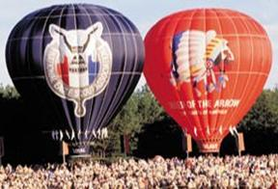
Hot air is less dense than cold air, in other words, you could say it weighs less. The contained hot air makes the balloon buoyant. Normally, the bigger the envelope, the more weight the balloon can carry aloft. Hot air balloons must carry fuel to burn in powerful heaters to keep the air in the envelope hot. Their airborne time is limited by the amount of fuel they can carry. The hot air balloon’s altitude is normally controlled by how hot the air in the envelope is—the hotter, the higher. Direction of flight is almost totally dependent on the direction of the wind. The balloon pilot will use different altitudes to find a desirable wind current. To make a rapid descent, and for landings, the pilot will vent the hot air through special openings in the envelope.

Gas balloons will use a lifting gas that is lighter than air, such as helium or hydrogen. Most modern day gas balloons will use helium since hydrogen is extremely flammable.

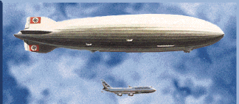
Airships
An airship is a lighter-than air aircraft that has propulsion and steering. Airships generally use gas filled envelopes, but there are a few hot air (thermal) airships around. Airships can be divided into two classes, rigid and non-rigid hulls. Rigid hull airships are known as dirigibles or zeppelins. Non-rigid hull airships are called blimps. Dirigibles use separate gas-bags within the main envelope, or hull. Their hull is further divided into useful compartments. The German airships the Graf Zeppelin, and the Hindenburg, were flying luxury hotels, with staterooms and dining rooms as well as cargo areas within the hull.

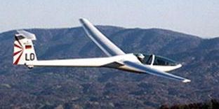
Gliders
Gliders are also referred to as sailplanes, and the sport of flying sailplanes is referred to as soaring. Sailplanes get their lift by using gravity as their propulsion. Sailplanes normally have sleek, long, very efficient wings. Some sailplanes can glide for over 60 miles from an altitude of 1 mile. Sailplanes use hot air too. Soarers look for thermals, or rising air currents, to help them gain altitude in order to soar even farther. The world record for distance flown is well over 1000 miles and sailplanes have climbed to over 50,000 feet. Sailplanes may be launched from the ground by tow vehicles or winches. Many places use tow aircraft to haul the sailplane to altitude. Gliders, towed by C-47 cargo aircraft, were used in World War II to haul troops and equipment into enemy territory.

Airplanes
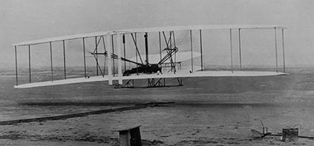
The Wright Flyer became the first powered, heavier-than-air machine to achieve controlled, sustained flight with a pilot aboard. Orville Wright flew the 1st successful flight on December 17, 1903, at Kitty Hawk, North Carolina.

That first flight lasted all of 12 seconds and covered a distance of 120 feet (less than the wingspan of some modern airliners). The airplane flew three more times that day, with Orville and his brother Wilbur trading places as pilot. Wilbur had the longest flight that day; it was 852 feet and lasted 59 seconds.

Rotorcraft
Rotorcraft can be divided into two classes, helicopters and gyroplanes.
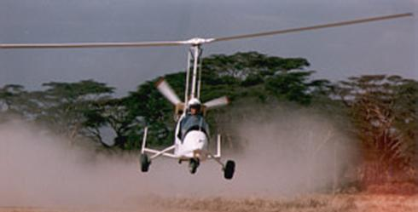
Gyroplanes
Gyroplanes have been around for decades. Gyroplanes are also known as gyrocopters, gyrodynes, autogyros, and autogiros. They were the first rotary wing aircraft to fly. Gyroplanes look like a cross between an airplane and a helicopter. A gyroplane has a fuselage like an airplane, and a propeller like an airplane to provide the propulsion, but it gets its lift by a rotor similar to that in a helicopter. Unlike the rotor in a helicopter, the rotor in an autogyro is not powered. It is made to spin by aerodynamic forces. This type of spinning is known as autorotation.

Helicopters
Helicopters fly by creating lift with a rotary wing. The helicopter gets its forward movement by tilting its rotor. In order to compensate for the torque created by the main rotor, helicopters use a tail rotor to provide directional stability.
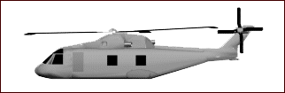
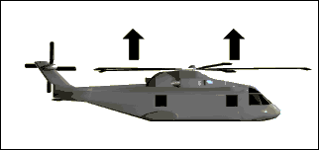

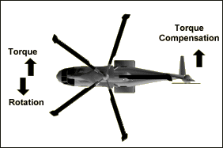

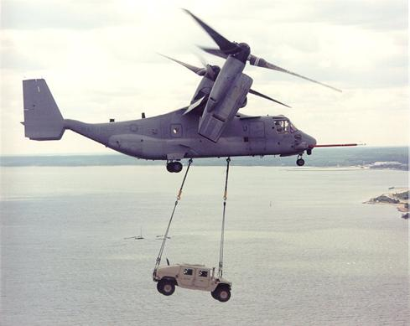

Powered Lift
Powered-lift aircraft are capable of taking off and landing like a helicopter, but, once airborne, its engine nacelles can be rotated to convert the aircraft to an airplane capable of high-speed, high-altitude flight.
Engine Types

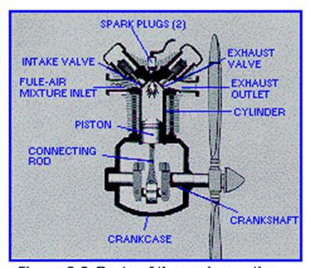
Piston Engine
The piston engine is also referred to as a “reciprocating-engine” in an aircraft. Some times you may hear it referred to as a “recip”.

Because the fuel mixture is burned within the engine the reciprocating engine is also known as an internal-combustion engine. To understand how a reciprocating engine works, we must first study its parts and the functions they perform.

The seven major parts are:
(1) The cylinders
(2) The pistons
(3) The connecting rods
(4) The crankshaft
(5) The valves
(6) The spark plugs
(7) A valve operating mechanism (cam).
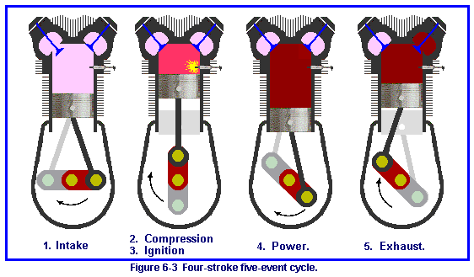
Engine Operation
The cylinder is closed on one end (this is called the cylinder head), and the piston fits snugly in the cylinder. The piston wall is grooved to accommodate rings, which fit tightly against the cylinder wall and help seal the cylinder’s open end so that gases cannot escape from the combustion chamber. The combustion chamber is the area between the top of the piston and the head of the cylinder when the piston is at its uppermost point of travel.

The up-and-down movement of the piston is converted to rotary motion to turn the propeller by the connecting rod and the crankshaft, just as in most automobiles.

Note the crankshaft, connecting rod, and piston arrangement in Figure 6- 2 and imagine how the movement of the piston is converted to the rotary motion of the crankshaft. Note particularly how the connecting rod is joined to the crankshaft in an offset manner.

The valves at the top of the cylinder open and close to let in a mixture of fuel and air and to let out, or exhaust, burned gases from the combustion chamber. A cam geared to the crankshaft opens and closes the valve. This gearing arrangement ensures that the two valves open and close at the proper times.

Event 1: The Intake Stroke
The cycle begins with the piston at top center; as the crankshaft pulls the piston downward, a partial vacuum is created in the cylinder chamber. The cam arrangement has opened the intake valve, and the vacuum causes a mixture of fuel and air to be drawn into the cylinder.

Event 2 & 3: Compression and Ignition Stroke
As the crankshaft drives the piston upward in the cylinder, the fuel and air mixture is compressed. The intake valve has closed, of course, as this upward stroke begins. As the compression stroke is completed and just before the piston reaches its top position, the compressed mixture is ignited by the spark plug.

Event 4: Power Stroke
The very hot gases expand with tremendous force, driving the piston down and turning the crankshaft. The valves are closed during this stroke also.

Event 5: Exhaust Stroke
On the second upward (or outward, according to the direction the unit is pointed) stroke, the exhaust valve is opened and the burned gases are forced out by the piston.

At the moment the piston completes the exhaust stroke, the cycle is started again by the intake stroke. Each piston within the engine must make four strokes to complete one cycle, and this complete cycle occurs hundreds of times per minute as the engine runs.

Turboprop Engine
The turboprop engine is an effort to combine the best features of turbojet and propeller aircraft. The first is more efficient at high speeds and high altitudes; the latter is more efficient at speeds under 400 mph and below 30,000 feet. The turboprop uses a gas turbine to turn a propeller. Its turbine uses almost all the engine’s energy to turn its compressor and propeller, and it depends on the propeller for thrust, rather than on the high-velocity gases going out of the exhaust. Strictly speaking, it is not a jet.

The gas turbine can turn a propeller with twice the power of a reciprocating engine. Reduction gears slow the propeller below the turbine’s rpm, and this must be done because of the limitations of propellers. That is, no propeller is capable of withstanding the forces generated when it is turned at the same rate as that of the gas turbine. Even so, the turboprop engine receives fairly extensive use in military and civilian aviation circles.

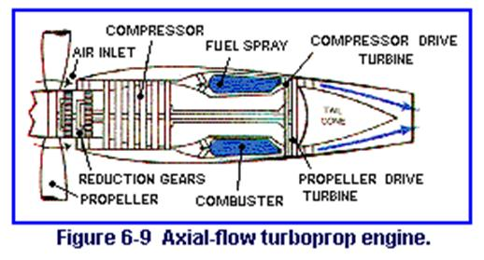
In summary, aircraft turbine engines may be classified as turbojet, turbofan, or turboprop. As a group, the turbine engines have many advantages over reciprocating engines, the most obvious being the capability of higher-altitude and higher-speed performance. Vibration stress is relieved as a result of rotating rather than reciprocating parts. Control is simpler because one lever controls both speed and power. With the large airflow, cooling is less complicated. Spark plugs are used only for starting, and the continuous ignition system of reciprocating engines is not needed. A carburetor and mixture control are not needed.

The major disadvantages have been the high fuel consumption and poor performance at low power setting, low speeds, and low altitudes. Turboprop and turbofan developments have greatly improved aircraft turbine engines in these areas.

Jet Engines
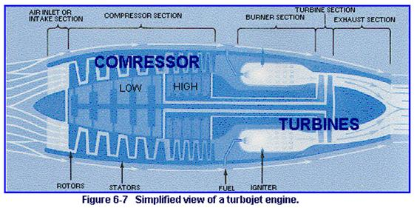
Turbojet
The turbojet uses a series of fan-like compressor blades to bring air into the engine and compress it. An entire section of the turbojet engine performs this function, which can be compared to the compression stroke of the reciprocating engine. In this section, there is a series of rotor and stator blades. Rotor blades perform somewhat like propellers in that they gather and push air backward into the engine. The stator blades serve to straighten the flow of this air as it passes from one set of rotor blades to the next.

As the air continues to be forced further into the engine, it travels from the low-compression set of rotors and stators to the high-compression set. This last set puts what we might say is the final squeeze on the air.

The combustion chamber receives the high-pressure air, mixes fuel with it, and burns the mixture. The hot, very high-velocity gases produced strike the blades of the turbine and cause it to spin rapidly. The turbine is mounted on a shaft, which is connected to the compressor. Thus, the spinning is what causes the compressor sections to function. After passing the turbine blades, the hot, highly accelerated gases go into the engine’s exhaust section.

The exhaust section of the jet engine is designed to give additional acceleration to the gases and thereby increase thrust. The exhaust section also serves to straighten the flow of the gases as they come from the turbine. Basically, the exhaust section is a cone mounted in the exhaust duct. This duct is also referred to as the tailpipe. The shape of the tailpipe varies, depending on the design operating temperatures and the speed-performance range of the engine.

With all the heat produced in the turbojet engine, you probably wonder how it is kept from overheating. Like most aircraft reciprocating engines, the jet is also air-cooled. Of all the air coming into the compressor section, only about 25 percent is used to produce thrust; the remaining 75 percent passes around the combustion chamber and turbine area to serve as a coolant.

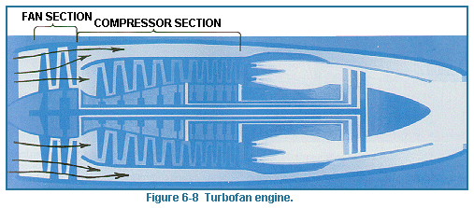
Turbofan
The turbofan engine has gained popularity for a variety of reasons. As shown in Figure 6-8, one or more rows of compressor blades extend beyond the normal compressor blades. The result is that four times as much air is pulled into the turbofan engine as in the simple turbojet. However, most of this excess air is ducted through bypasses around the power section and out the rear with the exhaust gases. Also, a fan burner permits the burning of additional fuel in the fan air stream. With the burner off, this engine can operate economically and efficiently at low altitudes and low speeds. With the burner on, the thrust is doubled by the burning fuel, and it can operate on high speeds and high altitudes fairly efficiently. The turbofan has greater thrust for takeoff, climbing, and cruising using the same amount of fuel than the conventional turbojet engine.

With better all-around performance at a lower ate of fuel consumption, plus less noise resulting from its operation, it is easy to understand why most new jet-powered airplanes are fitted with turbofan engines. This includes military and civilian types.

Forces Acting on an Airplane
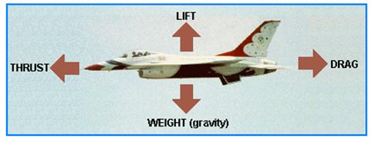
Lift is produced by a lower pressure created on the upper surface of an airplane’s wing compared to the pressure on the wing’s lower surface, causing the wing to be “lifted” upward. The special shape of the airplane wing (airfoil) is designed so that air flowing over it will have to travel a greater distance faster, resulting in a lower pressure area (see illustration) thus lifting the wing upward. Lift is that force which opposes the force of gravity (or weight).

Thrust is a force created by a power source which gives an airplane forward motion. It can either “pull” or “push” an airplane forward. Thrust is that force which overcomes drag. Conventional airplanes utilize engines as well as propellers to obtain thrust.

Drag is the force which delays or slows the forward movement of an airplane through the air when the airflow direction is opposite to the direction of motion of the airplane. It is the friction of the air as it meets and passes over and about an airplane and its components. The more surface area exposed to rushing air, the greater
the drag. An airplane’s streamlined shape helps it pass through the air more easily.

If the plane flies with a tail wind, that is, a wind whose airflow is also acting in the same direction as the direction of motion of the aircraft, the “drag” actually helps move the aircraft in the direction it wants to go. However, during takeoffs and landings, aircraft normally fly into the wind.

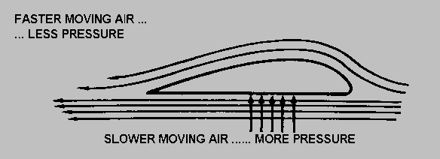
Lift

BERNOULLI’S PRINCIPLE
Daniel Bernoulli, an eighteenth-century Swiss scientist, discovered that as the velocity of a fluid increases, its pressure decreases. How and why does this work, and what does it have to do with aircraft in flight?

Bernoulli’s principle states that an increase in the velocity of any fluid is always accompanied by a decrease in pressure. Air is a fluid. If you can cause the air to move rapidly on one side of a surface, the pressure on that side of the surface is less than that on its other side. Bernoulli’s principle works with an airplane wing. In motion, air hits the leading edge (front edge) of the wing. Some of the air moves under the wing, and some of it goes over the top. The air moving over the top of the curved wing must travel farther to reach the back of the wing; consequently it must travel faster than the air moving under the wing, to reach the trailing edge (back edge) at the same time. Therefore the air pressure on the top of the wing is less than that on the bottom of the wing.

Control Surfaces

Control surfaces are the moveable outer surfaces of an airplane. These surfaces control the flow of air over the various sections of the aircraft causing it to move in different ways. Inside the airplane, pilots control the movement of the surfaces with their hands or feet by pushing, pulling or turning the controls to make the airplane move in the proper manner.

By learning the names and functions of the various surfaces, you will appreciate the construction, design, and aerodynamics of the airplane.

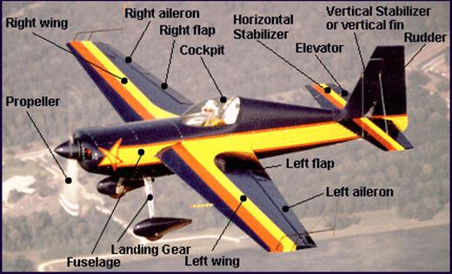
Airplane: An airplane is a vehicle heavier than air, powered by an engine, which travels through the air by the reaction of air passing over its wings.

Fuselage: The fuselage is the central body portion of an airplane, which accommodates the crew and passengers or cargo.

Cockpit: In general aviation airplanes, the cockpit is usually the space in the fuselage for the pilot and the passengers: in some aircraft it is just the pilot’s compartment.

Landing Gear: The landing gear, located underneath the airplane, supports it while on the ground.

Wings: Wings are the parts of airplanes which provide lift and support the entire weight of the aircraft and its contents while in flight.

Propeller: A propeller is a rotating blade located on the front of the airplane. The engine turns the propeller which most often pulls the airplane through the air.

Flaps: Flaps are the movable sections of an airplane’s wings closest to the fuselage. They are moved in the same direction (down) and enable the airplane to fly more slowly.

Ailerons: Ailerons are the outward movable sections of an airplane’s wings which move in opposite directions (one up, one down). They are used in making turns.

Rudder: The rudder is the movable vertical section of the tail which controls lateral movement.

Horizontal Stabilizer: The horizontal stabilizer is the horizontal surface of the aft part of the fuselage used to balance the airplane.

Elevator: The elevator is the movable horizontal section of the tail which causes the plane to move up and down.

Propellers

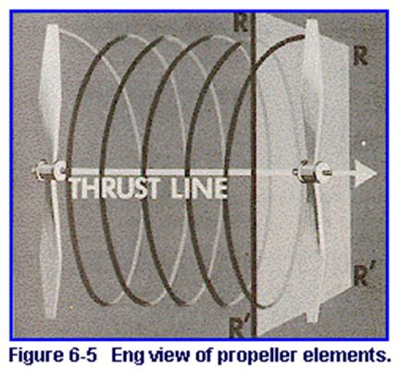
We can say that the propeller is the action end of an aircraft’s piston or turboprop engine, because it converts the useful energy of the engine into thrust as it spins around and around. The propeller has the general shape of a wing, but the camber and chord (curvature and cross-sectional length) of each section of the propeller are different. The wing provides lift upward, while the propeller provides lift forward.

The wing has only one motion, which is forward, while the propeller has forward and rotary motion. The path of these two motions is like a corkscrew as the propeller goes through the air.

Like a wing, a propeller blade has a thick leading edge and a thin trailing edge. The blade back is the curved portion and is like the top of a wing. The blade face is comparatively flat and corresponds to the underside of a wing. The blade shank is thick for strength and fits into a hub, which is attached to the crankshaft directly or indirectly. The outer end of the blade is called the tip.

Blade pitch is loosely defined as the angle made by the chord of the blade and its plane of rotation. When the angle is great, the propeller is said to have high pitch. A high-pitch propeller will take a bigger bit of air and move the aircraft farther forward in one rotation than will a low-pitch propeller.

Blade pitch is loosely defined as the angle made by the chord of the blade and its plane of rotation. When the angle is great, the propeller is said to have high pitch. A high-pitch propeller will take a bigger bit of air and move the aircraft farther forward in one rotation than will a low-pitch propeller. Propellers may be classified as to whether the blade pitch is fixed or variable. The demands on the propeller differ according to circumstances. For example, in takeoffs and climbs more power is needed, and this can best be provided by low pitch. For speed at cruising altitude, high pitch will do the best job. A fixed-pitch propeller is a compromise.

There are two types of variable-pitch propellers adjustable and controllable. The adjustable propeller’s pitch can be changed only by a mechanic to serve a particular purpose-speed or power. The controllable-pitch propeller permits pilots to change pitch to more ideally fit their requirements at the moment. In different aircraft, this is done by electrical or hydraulic means. In modern aircraft, it is done automatically, and the propellers are referred to as constant-speed propellers. As power requirements vary, the pitch automatically changes, keeping the engine and the propeller operating at a constant rpm. If the rpm rate increases, as in a dive, a governor on the hydraulic system changes the blade pitch to a higher angle. This acts as a brake on the crankshaft. If the rpm rate decreases, as in a climb, the blade pitch is lowered and the crankshaft rpm can increase. The constant-speed propeller thus ensures that the pitch is always set at the most efficient angle so that the engine can run at a desired constant rpm regardless of altitude or forward speed.

The constant-speed propellers have a full-feathering capability. “Feathering” means to turn the blade approximately parallel with the line of flight, thus equalizing the pressure on the face and back of the blade thereby stopping the propeller. Feathering is necessary if for some reason the propeller is not being driven by the engine and is wind-milling, a situation that can damage the engine and increase drag on the aircraft.

Most controllable-pitch and constant-speed propellers also are capable of being reversed. This is done by rotating the blades to a negative or reverse pitch. Reversible propellers push air forward, reducing the required landing distance as well as reducing wear on tires and brakes.

DIRECTIONAL CONTROL
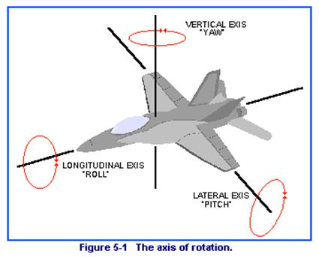
An airplane in flight changes direction by movement around one or more of its three axes of rotation: lateral axis, vertical axis, and longitudinal axis. These axes are imaginary lines that run perpendicularly to each other through the exact weight center of the airplane. The airplane’s rotation around them is called pitch, roll, and yaw. The pilot guides the airplane by controlling pitch, roll, and yaw, and by use of the elevators, ailerons, and rudder.

YAW Rudder rotates the airplane around vertical axis.
ROLL Ailerons rotate the airplane around longitudinal axis.
PITCH Elevators rotate airplane around lateral axis.

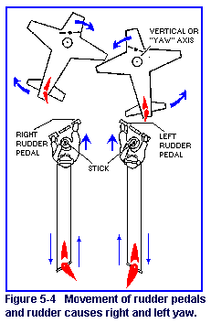

The Vertical Axis – Yaw

Rudder: The foot pedals are connected by means of wires or hydraulics to the rudder of the tail section. The rudder is the vertical part of the tail that can move from side to side.

The foot pressure on the left rudder pedal moves the rudder to the left, causing the nose of the airplane to move to the left.

The foot pressure on the right rudder pedal moves the rudder to the right, causing the nose of the airplane to move to the right.

The Longitudinal Axis – Roll

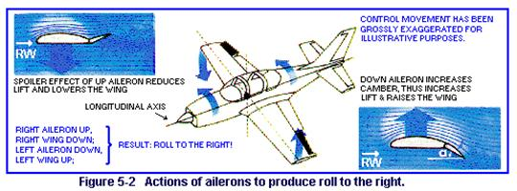
Ailerons: The stick is connected by means of wires or hydraulics to the wings’ ailerons. By turning the stick, the pilot can change the positions of the ailerons.

When the control wheel is turned to the right, the right aileron goes up and the left aileron goes down,
rolling the airplane to the right.

When the control wheel is turned to the left, the right aileron goes down and the left aileron goes up, rolling the airplane to the left.
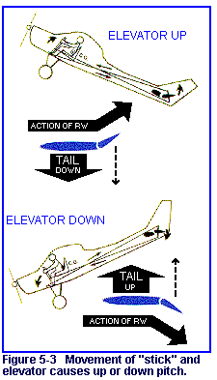

The Lateral Axis – Pitch

Elevators: The stick (joy stick) is connected by means of wires or hydraulics to the tail section’s elevators. By moving the stick, the pilot can change the position of the elevators.

When the control column is pushed in, the elevators move down, pitching the tail of the airplane up an the nose down, rolling the airplane down.

When pulling the control column back makes the elevators move up, pitching the tail of the airplane down and the nose up, rolling the airplane upwards.

Cars go only left or right, but planes must be steered up or down as well. A plane has parts on its wings and tail called control surfaces to help it. These can be demonstrated by use of folded paper gliders and balsa gliders. Let’s start with an experiment to illustrate how a plane is controlled.

Takeoff and Climb

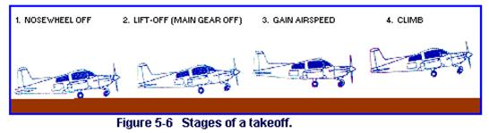
After taxiing to the runway, a pre-takeoff checklist is accomplished. This check is to ensure that all systems are working normally. When this is completed, the airplane is taxied to the center of the runway and aligned with it. The throttle is opened fully to start the takeoff run (also called take off roll). During this takeoff run, the control wheel, or stick, is usually held in the neutral position, but the rudder pedals are used to keep the airplane on the runway’s centerline.

As takeoff airspeed is approached, gentle backpressure on the control wheel raises the elevator, which causes the airplane’s nose to pitch upward slightly. This lifts the nose wheel off the runway.

Once the nose wheel is off the runway, the right rudder is applied to counteract the left-turning tendency, which is present under low airspeed and high-power flight conditions. As the airplane lifts dear of the runway, the pilot varies the pressure on the control wheel. First, pressure is relaxed slightly to gain airspeed while still in ground effect (additional lift provided by compression of air between the airplane’s wings and the ground). As airspeed increases to the best rate-of-climb airspeed, back pressure on the control wheel is adjusted to maintain that airspeed until the first desired altitude is reached. (Best rate-of-climb airspeed provides the most altitude for a given unit of time.) Climbs to other and higher altitudes are made at airspeeds determined by the pilot, until the desired cruising altitude is reached.

Upon reaching cruising altitude, the airplane’s pitch attitude is reduced and the airplane accelerates to cruising speed. The power is reduced and adjusted to maintain the selected cruising speed. Almost simultaneously, the pilot adjusts the elevator and possibly the rudder to keep the airplane at the desired altitude and heading (direction). If the flight is to go to a distant airport, the airplane will be kept in its cruising flight configuration until the destination is near. If the pilot wants only to perform basic flight maneuvers in a practice area, the cruising flight configuration will necessarily be changed rather soon.

Landing

A good landing begins with a good approach. Before the final approach is begun, the pilot performs a landing checklist to ensure that critical items such as fuel flow, landing gear down, and carburetor heat on are not forgotten. Flaps are used for most landings because they permit a lower- approach speed and a steeper angle of descent. This gives the pilot a better view of the landing area. The airspeed and rate of descent are stabilized, and the airplane is aligned with the runway centerline as the final approach is begun. When the airplane descends across the approach end (threshold) of the runway, power is reduced further (probably to idle). At this time, the pilot slows the rate of descent and airspeed by progressively applying more back pressure to the control wheel. The airplane is kept aligned with the center of the runway mainly by use of the rudder.

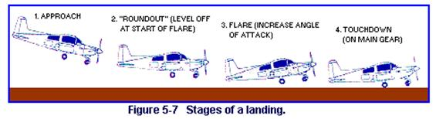
Continuing backpressure on the control wheel, as the airplane enters ground effect and gets closer and closer to the runway, further slows its forward speed and rate of descent. The pilot’s objective is to keep the airplane safely flying just a few inches above the runway’s surface until it loses flying speed. In this condition, the airplane’s main wheels will either “squeak on” or strike the runway with a gentle bump. With the wheels of the main landing gear firmly on the runway, the pilot applies more and more backpressure on the control wheel. This holds the airplane in a nose-high attitude, which keeps the nose wheel from touching the runway until forward speed is much slower. The purpose here is to avoid overstressing and damaging the nose gear when the nosewheel touches down on the runway. The landing is a transition from flying to taxiing. It demands more judgment and technique than any other maneuver. More accidents occur during the landing phase than any other phase of flying. Variables such as wind shear and up-and-down draft add to the problem of landing. Good pilots can be easily recognized. They land smoothly on the main wheels in the center of the runway and maintain positive directional control as the airplane slows to taxiing speed.

Certificates

Recreational Pilot Certificate
With a Recreational Pilot Certificate, a person is qualified to act as pilot-in-command of a single-engine aircraft carrying 1 passenger. A person with Recreational Pilot Certificate may only fly under day visual fight rules (VFR). In other words, the pilot may fly only in the daytime with good weather conditions. A Recreational Pilot may not receive compensation (can’t get paid or receive gifts) for his/her services. A Recreational pilot must meet currency requirements and is limited to a 50 nautical mile range.

The FAA requires a minimum of 30 hours of logged flight training to obtain the certificate.

Here are some of the requirements you need to be eligible according to 14CFR 61.96 (14CFR is what is commonly known as the FARs):
- At least 17 years of age;
- Read, speak and understand English;
- Hold at least a third class medical;
- Receive an endorsement from an instructor who gave or reviewed the applicants ground training and certified that the student is prepared for the knowledge test;
- Receive an endorsement from an instructor who gave the applicant’s flight training and certified that the student is prepared for the knowledge test;
- Pass a written exam (knowledge test);
- Meet the aeronautical experience requirements;
- Pass an oral and flight test.

Private Pilot Certificate
With a Private Pilot Certificate, you can act as pilot-in-command of an aircraft carrying passengers and baggage. A private pilot (without an instrument rating) may only fly under visual fight rules (VFR). In other words, the private pilot may fly during the day or night, but still only in good weather conditions. The private pilot may not receive compensation for his/her services either (you must have at least a Commercial Pilot Certificate to get paid to fly). You will still have some currency requirements as a private pilot, but you are not limited to any flight radius.

The FAA requires a minimum of 40 hours (Part 61-Regular flight school) or 35 hours (Part 141-Formal flight school) of logged flight training.

Here are some of the requirements you need to be eligible according to 14CFR 61.103:
- 17 years of age for airplane or helicopter certificate. You may solo an airplane, or get a glider or balloon certificate at 16;
- Read, speak, understand, and write English;
- Receive an endorsement from an instructor who gave or reviewed the applicants ground training and certified that the student is prepared for the knowledge test;
- Pass a knowledge test;
- Receive an endorsement from an instructor who conducted the applicants training and certified the applicant is prepared for the practical test;
- Meet the aeronautical experience requirements.
- Pass an oral and flight test.

Instrument Rating
With an instrument rating, a pilot can fly the aircraft by solely using the flight instruments within the aircraft. When flying using visual flight references (VFR), the pilot uses objects outside the aircraft, such as the horizon, to control and maneuver the aircraft. When flying using instrument flight references (IFR), the pilot uses the instruments within the aircraft to fly. In order to fly IFR a pilot must earn an instrument rating.

All professional pilots are instrument rated. With an Instrument Rating, the pilot doesn’t have to depend on clear flying days to enjoy a flight. Getting an instrument rating also makes a pilot a safer, more skillful flier.
The FAA requires a minimum of 125 hours (Part 61-Regular flight school) of logged flight time. At least 50 hours of flight time must be cross-country time (not a local flight).

Here are some of the requirements you need to be eligible according to 14CFR 61.65:
- Hold at least a private pilot certificate (with appropriate aircraft rating);
- Read, speak, understand, and write English;
- Receive and log ground training from an instructor or home-study course on the aeronautical knowledge areas required;
- Receive an endorsement from an instructor who gave or reviewed the applicants ground training and certified that the student is prepared for the knowledge test;
- Receive and log training in the areas of operation required from an instructor in an aircraft, simulator, or training device appropriate to the rating sought (helicopter, airplane etc.);
- Receive an endorsement from an instructor who conducted the applicant’s training and certified the applicant is prepared for the practical test;
- Pass a knowledge test;
- Pass an oral and flight test

Aircraft Instruments
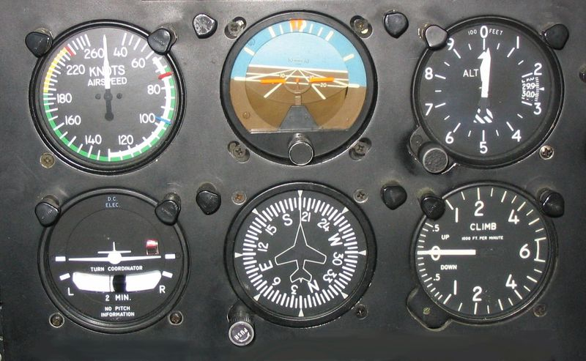
Airspeed indicator - This displays the speed at which the airplane is moving through the air. The airspeed indicator is one of the pressure instruments using the pitot-static system. Most airspeed indicators use a combination of impact air pressure (from the pitot tube) and static air pressure (from static ports) to give a correct reading. The airspeed indicator in the figure is indicating an airspeed of 135 knots (nautical miles per hour). Most modern aircraft use knots to measure speed. A nautical mile is 6,076 feet. Your family car uses statute miles per hour. A statute mile equals 5,280 feet.

Attitude indicator - This is also called the Artificial Horizon. This displays the attitude of the airplane (nose up, nose down, wings banked) in relation to the horizon. The attitude indicator is a gyroscopic instrument; that means it uses a gyroscope to maintain its relative position. In most smaller, private aircraft, the attitude indicator’s gyroscope is spun by high speed air provided by a suction (vacuum) pump mounted on the aircraft engine. The attitude indicator in the figure is indicating level flight (nose and wings are level in relation to the horizon).

Altimeter - This displays the altitude of the airplane above mean sea level (MSL) when properly adjusted to the current pressure setting. The altimeter uses static air pressure provided by the pitot-static system’s static ports. The little knob you see adjusts the altimeter to the local barometric pressure to provide an accurate reading. The pilot simply adjusts the altimeter until the correct barometric pressure is set in the little window (the Kollsman window).

Turn and Bank Indicator - This is also known as the Turn Coordinator, or sometimes Turn and Slip Indicator. The Turn and Bank indicator displays the rate at which a turn is being made. The “Turn” portion of the indicator is a gyroscopic instrument. If you have a vacuum driven attitude indicator, you would want to have this important back-up instrument use another power source (usually the plane’s electrical system). The miniature airplane banks in the direction of the turn. At the bottom of the instrument is a ball in a glass tube called an inclinometer. The inclinometer uses gravity and inertia to indicate aircraft movements called slips and skids. The inclinometer indicates whether the airplane is in coordinated flight (centered) or uncoordinated flight. The turn coordinator in the figure is indicating wings level and coordinated flight.
Heading indicator - This displays the heading (direction) the airplane is flying. This is also a gyroscopic instrument. The indicator is not a compass so it must be set to agree with the aircraft’s magnetic compass. Compasses are notoriously unreliable when an aircraft turns, changes pitch, or airspeed. For this reason, pilots use a system that maintains accuracy in all phases of flight—a gyroscopically driven indicator. In most smaller, private aircraft, the heading indicator’s gyroscope is also spun by high speed air provided by a suction (vacuum) pump mounted on the aircraft engine. The heading indicator in the figure is indicating a heading of north.
Vertical speed indicator - Also known as the VSI or VVI for military pilots. The VSI uses static pressure from the pitot-static system to give its readings. The VSI displays whether the airplane is in level flight, climbing, or descending. The rate of climb or descent is indicated in hundreds of feet per minute. The VSI in the figure indicates level flight.

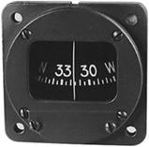
Compass - This is pretty much just like the compass you use in orienteering. Remember it is only reliable in level, un-accelerated flight. When you put a compass in an aircraft you must also take care to compensate for any metals in the aircraft which may cause deviations.

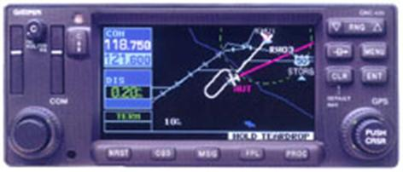
Comm/Nav Radios - Pictured is a combination radio which allows the pilot to communicate with Air Traffic Control and use GPS to navigate. This example even uses a virtual moving map to display the aircraft position.

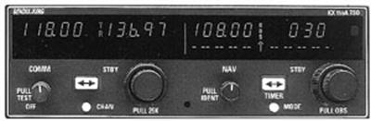
This is a combination VOR navigation and VHF communication radio. Both this and the GPS/COM radio pictured above can be linked to another instrument used to provide guidance for the airplane to fly an instrument approach and enroute navigation.

Tachometer - This is a digital tachometer or tach. Just like one you may find in your car, pilots use it to keep track on how fast the engine is revving.
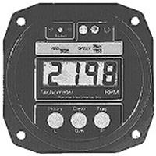

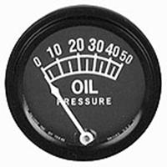
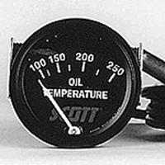
Oil Pressure and Oil Temperature Gauges - These to instruments are important to have on your powered aircraft. They provide an indication of lubrication and temperature of your engine. Any change from normal indications gives the pilot an advance notice to ensure the engine continues to operate normally.

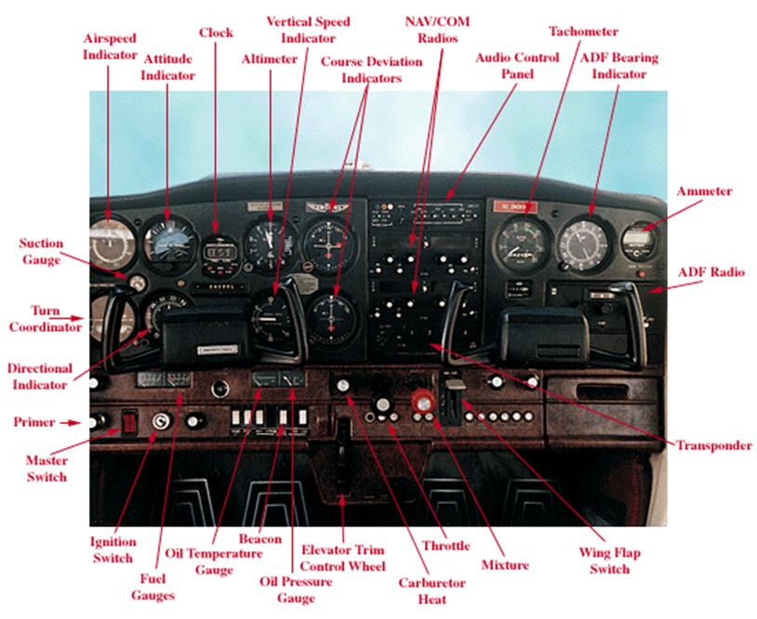
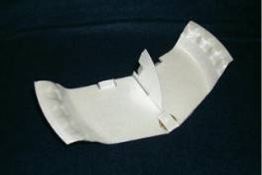
FPG-9 Styrofoam® Plate Glider

Objective: This simple design requires only a foam plate, a little ambition, and even less time. The FPG-9 plane is a basic illustration of how flight works.

Description: The FPG-9 is constructed from a 9” foam plate. Just two pieces are traced from a pattern, cut out and assembled.

Materials: The materials and tools necessary are:
- FPG-9 pattern
- 9” foam plate
- Scissors
- Clear tape
- Ink pen
- Penny

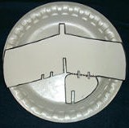
Note – Since a paper pattern is hard for students to trace around, the instructor may want to cut out a foam plate master template for the students to use to trace around.

1. Cut out the paper FPG-9 pattern. Do not cut along the dotted line on the paper pattern. Only cut along the bolded lines.

2. Place the paper pattern in the center of the foam plate ensuring that the tail of the pattern stays inside of the curved portion of the plate bottom. (The tail must remain on the plate’s flat bottom.) It’s fine if the tab on the front of the pattern is on the curved portion. The ends of the wings should spill over the curved edge of the plate.

3. Trace around the pattern with an ink pen. Don’t forget to mark the scissor slits A and B.

4. Cut the foam template out by following the pen lines you just drew.

5. Once the instructor has completed the master foam template, the students may use the template to create their FPG-9 planes.

6. Have the students place the foam template in the center of the plate and trace around the template making sure to mark all of the lines.

7. When tracing slits A and B the students only need to make one line. These lines will create the elevons and rudder.

8. Have the students cut out the FPG-9 they just traced by following the pen lines.

Important Note – At this time cut along the dotted line to separate the tail from the wing of the FPG-9. It works better if you make all of your cuts from the outside of the plate towards the center of the plate. Do not try to turn your scissors to cut sharp corners. When cutting out the slots, make them only as wide as the thickness of the foam plate. If the slots are cut too wide the pieces of the plane will not fit together snuggly.

9. The wing and the tail each have slits drawn on them. Have the students make a cut along each of these lines as drawn.

10. To attach the tail to the wing, slide Slot 1 into Slot 2. Use two small (2”) pieces of tape to secure the bottom of the tail to the bottom of the wing. Ensure the tail is perpendicular to the wing before adding the tape.

11. In order to make the plane fly successfully, the students must attach a penny on top of the wing right behind the square tab. Fold the tab back over the penny and tape it down to secure the coin.

12. Bend the elevons on the wing upward. This will provide for a flatter glide. If the students want the plane to turn they can adjust the rudder on the vertical fin.

13. Your FPG-9 is complete and ready to fly. Gently toss the plane directly in front of you. Once it flies reasonably straight ahead and glides well, try throwing it hard with the nose of the glider pointed 30° above the horizon. The FPG-9 should perform a big loop and have enough speed for a glide of 20 – 25 feet after the loop.
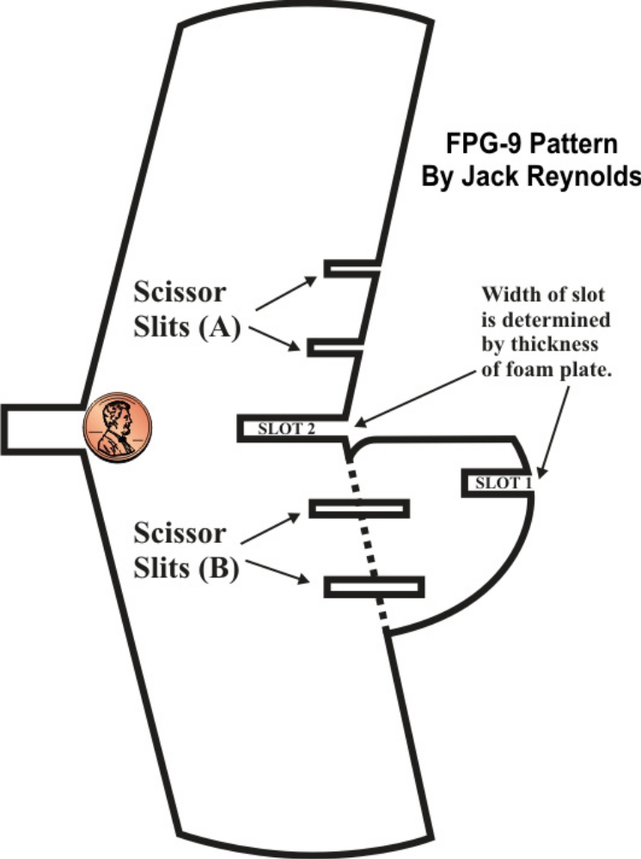
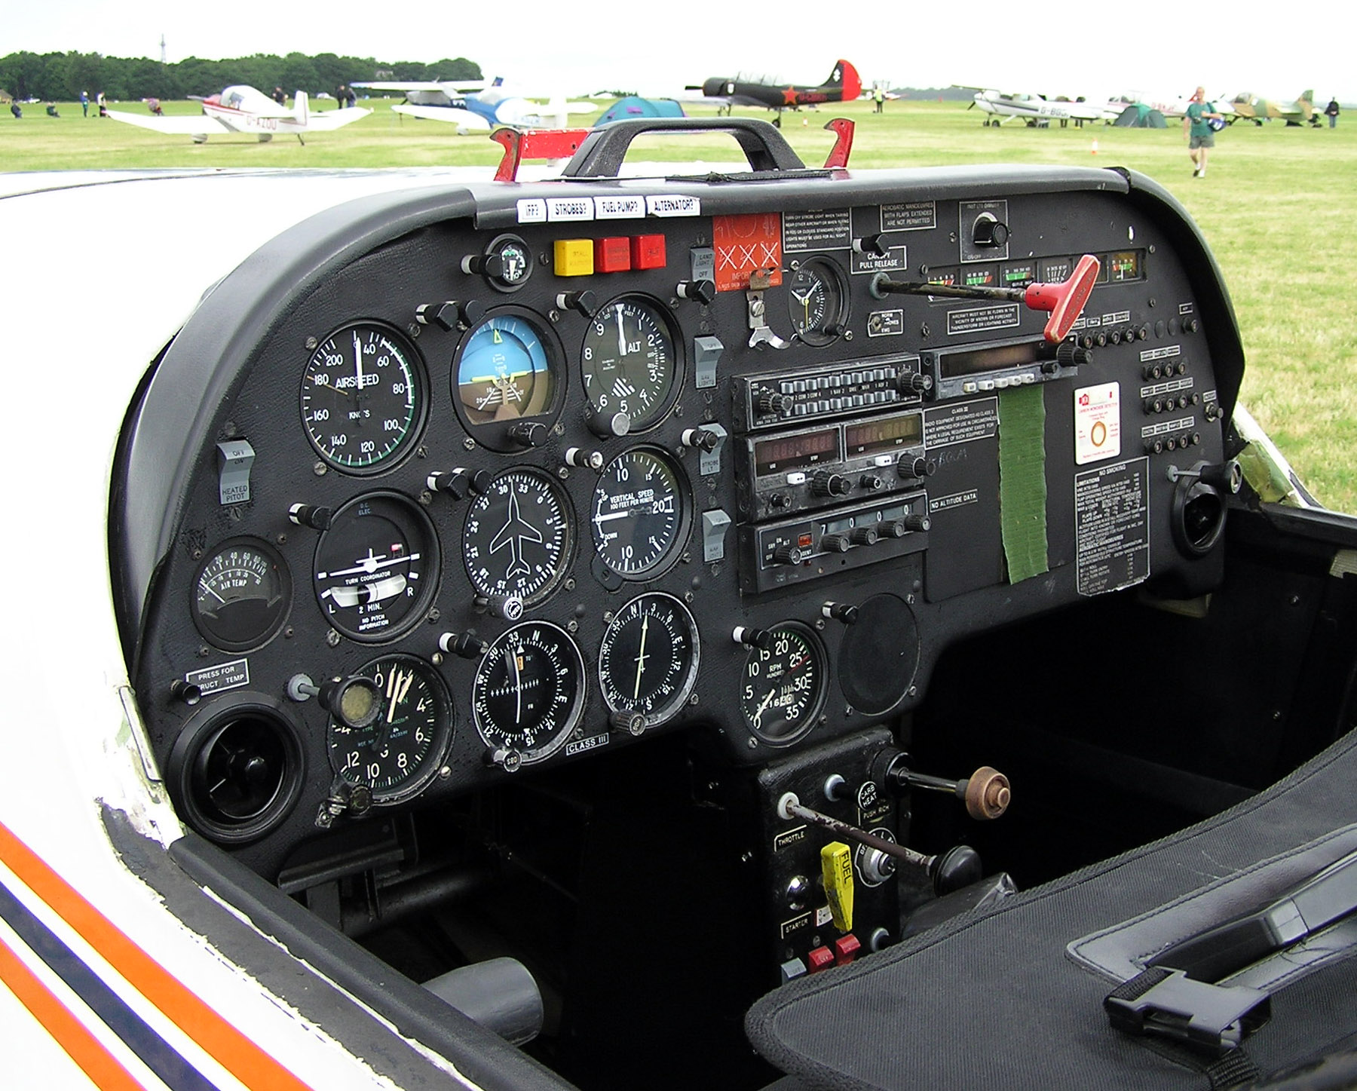
COM/NAV radio

